Lesson 6 Lesson-End Project
Provision EC2 using Terraform

Project Agenda: To automate provisioning of an AWS EC2 instance using Terraform.

Description: You are a DevOps Engineer in an IT company. Your company wants you to automate an infrastructure to manage all the running services from one place and provide an access model control based upon the organisation, teams, and users.This should also help the team in better collaboration and a centralised documentation.

Tools required: Terraform, AWS CLI.

Pre-requisites: You must have Terraform installed in your local system and also AWS CLI. You should also have an AWS account to have the access details.

Expected Deliverables: Configure AWS in your local system and aunch an EC2 instance using Terraform.

Steps to be followed:
- Prepare your machine
- Prepare Terraform scripts
- Apply your Terraform scripts

Step 1: Prepare your machine

1.1. Have your security credentials handy to authenticate to your AWS Account.
1.2 Execute the following command to set up your AWS credentials as environment variables. The playbook will need these at runtime.

aws configure
Enter your AWS access key
Enter your AWS secret access key
Region: us-east-1
Default output format: none

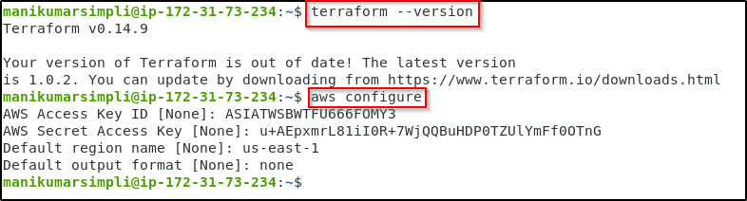

Note: The configuration process stores your credentials in a file at ~/.aws/credentials on MacOS and Linux, or %UserProfile%\.aws\credentials on Windows.

1.3 Verify the entered details and then add security token manually(You can skip adding security token in case you are using your own AWS root account)

cd .aws
nano credentials
To save: ctrl+x and then press y and enter

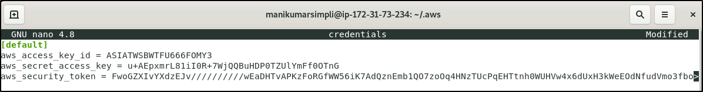
1.4 Run the below commands in the given sequence to set up your AWS CLI:

pip install awscli
sudo apt-get update

Step 2: Prepare Terraform scripts

2.1 Run a cd command to move to the home directory

Create a new folder:
mkdir ec2demo

Move to the folder:
cd ec2demo

Create creds.tf file:
nano creds.tf

Enter the following code:
provider "aws" {
access_key = "AWS_LAB_ACCESS_KEY"
secret_key = "AWS_LAB_SECRET_KEY"
token = “AWS_LAB_SECURITY_TOKEN”
region = "us-east-1"
}

Note: Use the credentials given in your AWS lab and replace the placeholders of Access key, Security key, and Security Token with the corresponding values.

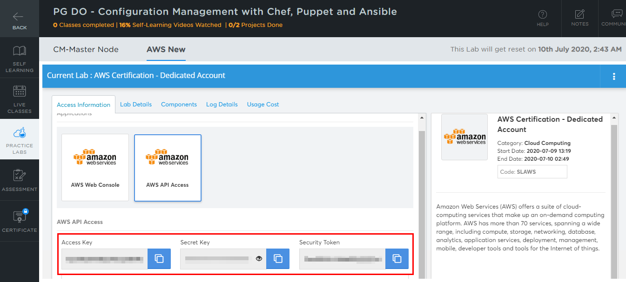

2.2 To save: ctrl+x and then press y and enter

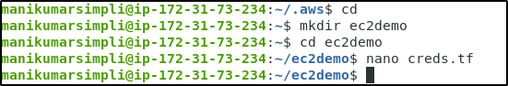
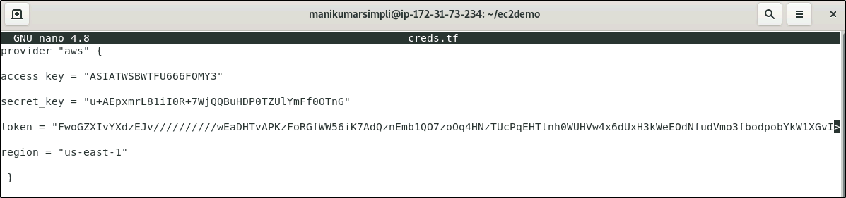
2.2 Create a file to define your infrastructure i.e ec2.tf and enter the below code:

Create a file using the below command:

nano ec2.tf

Enter the below code:

resource "aws_instance" "example" {
ami = "ami-2757f631"
instance_type = "t2.micro"
}

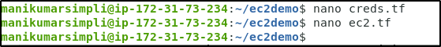
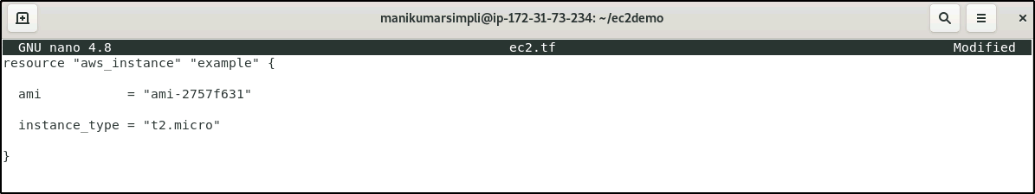
Step 3: Apply your Terraform scripts
3.1 When you create a new configuration — or check out an existing configuration from version control — you need to initialize the directory with terraform init
terraform init

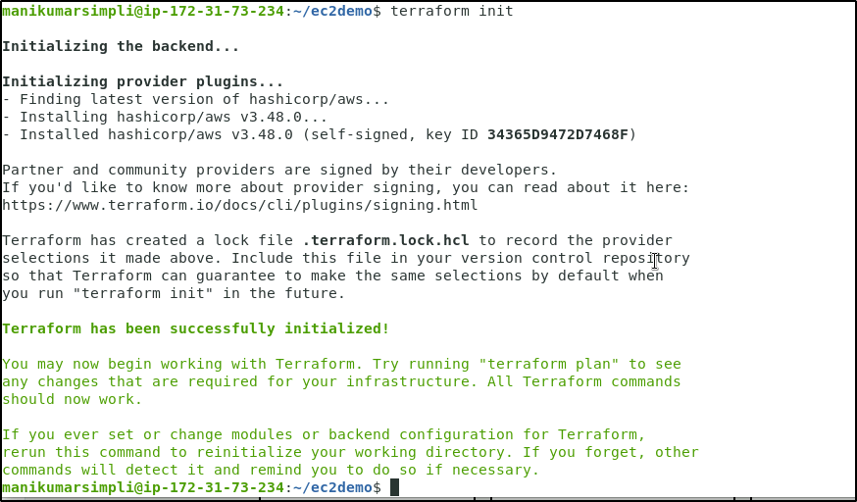
3.2 Apply the configuration now with the terraform apply command
terraform apply
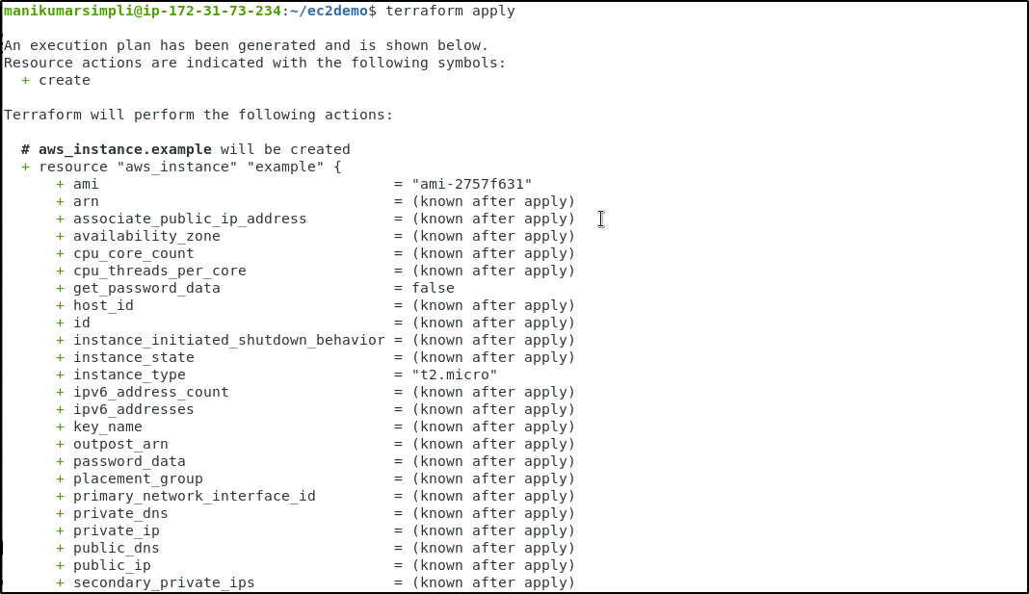

Terraform will pause and wait for your approval before proceeding

Enter a value: Yes
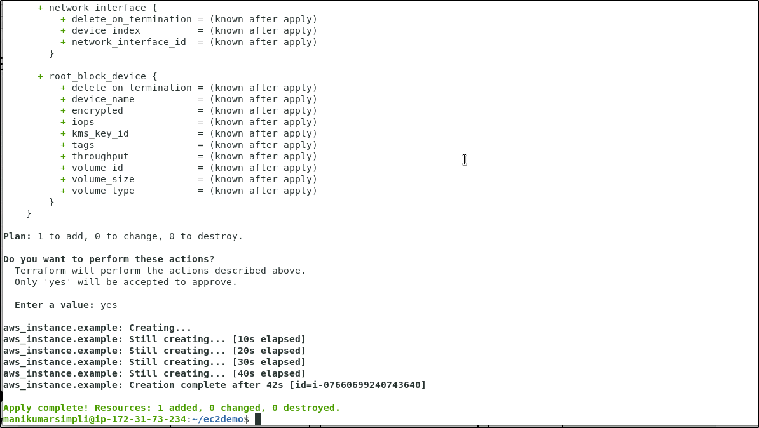

3.3 Verify the creation of EC2 instance in your AWS management console
